

**CS 890EP - Internet of Things**

**Supervised by**

**Dr. Maher Elshakankiri**

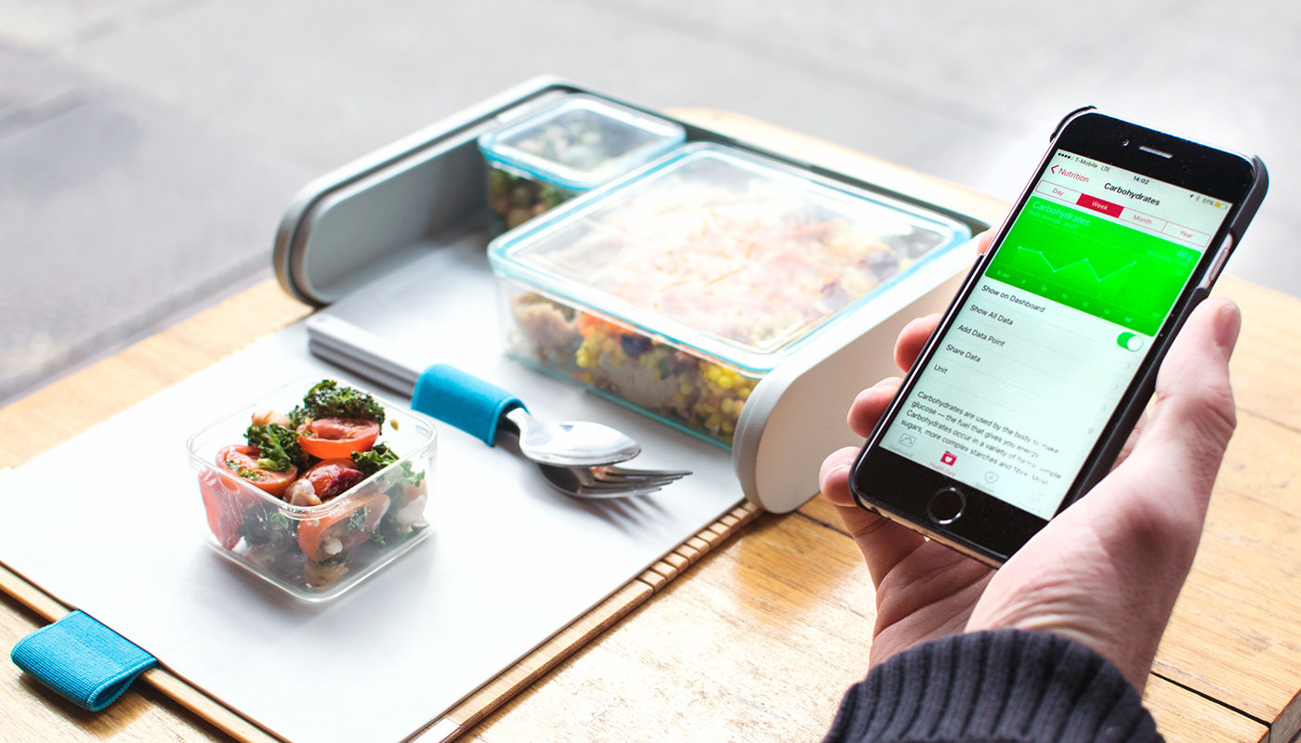[4]

**Smart Lunch Box**

**Submitted by**

**Keerthi Mettu**

**200416252**

**SMJ102@uregina.ca**

**Introduction:**

Over the past few decades technology has been growing rapidly. Internet of things is a necessary tool for today world which we use in our present life and a lot of applications improved efficiency by using it. IoT (Internet Of Things) is utilized in multiple technologies to solve various problems which exist in today’s world. The unique part of IoT applications is that all the devices are connected over the internet, controlled and monitored remotely.

To illustrate, various technologies involved in enabling the Internet of Things are Radio Frequency Identification (RFID), Near field communication (NFC), Wireless Sensor Network (WSN), Different Networks for communication, Augmented Intelligence, Augmented Behavior.

Of all these technologies, WSN plays a prominent role in the development and growth of IoT applications. A wireless sensor network is defined as a group of Wireless devices that are connected over the network [5]. These devices can sense and monitor the real-time environment as well as exchange information between nodes. Each node has a predefined task. WSN consists of a base station, nodes which are sensors. Sensors sense the data and forward the data to the base stations. Overall tasks performed by wireless sensor networks is to gather the sensed data, Process the data, transfer the data using packets. Depending upon the application appropriate sensors like Temperature Sensor, Light Sensor, Pressure Sensor, Humidity Sensor, Touch Sensor, Tilt Sensor, IR Sensor, etc. are used.

Healthy human survival and lifestyle depend on the food we eat. Mindful eating is very much required for anyone who wants to take control of the food intake. Calories are the basic measuring unit of energy produced from food and it varies for different food sources. Mindful eating not only involves the calorie check on the food, but also the measure of nutrition values absorbed from them. Basically, the food components are classified as carbohydrates, proteins, and fats. Keeping a count on the amount of these components accurately on a routine basis helps the individuals to monitor the calorie intake. This is also a major requirement for any person who wants to follow a diet and maintain it as a conscious eating habit.

There are several applications on the internet to identify the calorie count for the food that is chosen. Although there are smart devices that aid in the temperature control of the food, there are certain limitations in terms of availability, accuracy and safety. Some devices like smart lunch boxes have to be introduced that can address the technical requirements of the users using necessary. A smart lunch box can be created as an Internet of Things device, that is capable of notifying the user about their lunch timings through an alarm, calculating the calories of the food present in the box and heating the food. For the sake of kid’s nutrition, it should be designed in a way to identify the food completion level in the lunch box along with the authentication, so that the box opens only for the respective users.

**Keywords:** Weighing module, temperature sensor, WIFI module, touch sensor, Alarm, Buzzer.

**Related work:**

Albert tian proposed a design for a lunch box, where it has a heating facility to warm up the food before eating [1]. This smart box uses a positive temperature coefficient heater as a heating element, which has an open loop control and doesn’t need an external diagnostic. Prepd describes a Prepd app [2], that gives information about the food, that can be prepared for a week before it starts. It helps to give the measures of the food nutrients that will be taken by the user and a broad range of diets, appetites, and health goals. Silbo Tech [3] designed a lunch box with the features like heating and cooling techniques, Bluetooth connection for phones to get notifications regarding the lunch box state and the charging feature like a power bank to electronic devices through USB connections. It also includes a safety sensor and a temperature sensor to get to know the temperature of food inside the lunch box.

**Problem Statement:**

Intake of calories and food consumption affects a person’s healthy lifestyle and living. Proper calorie intake and nutrition play an important role in one's diet. Now a days, being in a busy lifestyle, most of the people are unable to concentrate on the food they are consuming. Even the ones who want to become health conscious, are trying to carry their own food prepared, boxes, but they are not able to get the exact amount of nutrition acquired from it. Also, due to hustle life, people will never take note of the number of calories they take on per meal.

Most of the software applications that do the calorie sum of the food, ask for the quantity of the respective food item. If we don’t provide these values accurately, there would be variations in the amount of calories consumption for that day. It would not help a person to keep track of their diet in a systematic manner. It is also a major drawback for the ones who have goals without the help a nutritionist on weight loss or weight gain nutrition plan.

A lot of students bring their own lunch boxes to school and most employees prefer carrying their home food. Sometimes there won’t be any microwave or outlets to warm up their food. It also has a risk of food stewing in its own moisture, which results in the food becoming soggy and unappetizing.

On the other side, parents who send lunch boxes to their kids are very much concerned about their nutrition. It is always a big quest for them to know whether their kid actually had lunch or just threw the food to the dustbin.

It is really important to maintain a scheduled food time every day, in order to have an undisturbed biological clock in the body. Usually, people will forget to have their lunch on time due to the heavy workload. They need regular reminders about their lunch timings. A smart lunch box can be designed to solve all the above-mentioned problems.

**Methodology:**

A smart lunch box is designed to address all the issues described in the problem statement. As the IoT is an emerging technology with various sensors, a smart lunch box is designed using this technology. The term “smart” itself indicates that the lunch box is designed to act intelligently to maintain a conscious eating habit for a respective group of users like adults and kids. Following are the different modules implemented as a part of a smart lunch box.

1. *Weight the food in sections:* A smart lunch box is designed in such a way that many different size compartments are present inside it. Every compartment can go with a single food item. Each compartment has its own weighing module, the primary component of this module is load cell sensor along with a force sensor so accurate weight of each component can be obtained. These values are populated to the app where they are used in the next module.
2. *Calorie calculator:* The weight noted in the initial module is supplied as the input for this module. In this module, all the information about each type of food along with its carbs, protein and fat percent information is stored in the database. In the designed application there will be an interactable picture of smart box compartment. When an item is placed in the smart lunch box compartment, its respective weight will automatically be reflected in the designed app. Through this, the user has to enter the food item name manually by selecting the compartment. If the food item is already loaded in the database, the app checks its respective calories and gives accurate information about the carbohydrates, proteins, fats and other nutritional information in the form of a percentage. A final sum of calories per meal can also be indicated at the end of entering the food data.
3. *Automatic Heating Control:* Smart lunch box should have a heating element where it warms up the food present in lunch boxes by pressing the button. Resistors coil can be made and surrounded around the compartments present in the lunch box. A particular time is set through an app for heating up their smart box to warm up the food in the container. This solves the issue for not waiting too long for the microwave to heat their lunch boxes.
4. *Alarm signaling:* This module is designed especially for the people who are busy in their life as they forget about their intake of food. An alarm will help the user to remember to take their food at lunchtime. Buzzing can be stopped by using a button present on the lunch box or by operating it through the app. This alarm can also be used for different purposes like buzzing to clean the container and trigger to take the lunch box before leaving the house.
5. *Touch Authentication:* This module is specially designed for school going kids. As kids don’t have control on losing their boxes, there may be cases that their friends may take away their lunch boxes without any indication. Apart from this as this is a smart lunch box, the box should be opened in a smart manner rather than using the traditional box open method.
6. *Empty Box Notification:* This is a unique module for parents who are more concerned about their children. This would let them know as a notification in the app whether their kid is having the meal or throwing away the food from the lunch box.

**Team Workload:**

|  |  |
| --- | --- |
| **Name** | **Modules** |
| Keerthi | 2,4 |
| Sravya | 1,5 |
| Kiranmai | 3,6 |

**References:**

1. Kickstarter. (2019). *Smart Lunchbox*. [online] Available at: https://www.kickstarter.com/projects/342822390/smart-lunchbox [Accessed 31 May 2019].
2. Kickstarter. (2019). *Prepd Pack - The Lunchbox Reimagined*. [online] Available at: https://www.kickstarter.com/projects/prepd/prepd-pack [Accessed 31 May 2019].
3. Indiegogo. (2019). *Silbo - The World's First Smart LunchBox*. [online] Available at: https://www.indiegogo.com/projects/silbo-the-world-s-first-smart-lunchbox#/ [Accessed 31 May 2019].
4. Engadget.com. (2019). *Engadget is now a part of Oath*. [online] Available at: https://www.engadget.com/2016/01/19/prepd-pack-lunchbox-healthkit/ [Accessed 31 May 2019].
5. Network (WSN) Architecture And Applications. [online] Available at:<https://www.elprocus.com/architecture-of-wireless-sensor-network-and-applications>[Accessed 22 May. 2019].